SIMATS ENGINEERING
CO- 2: AT – 2: Simulation Task - Medium
COURSE NAME: Advance Wireless Communication Systems /
5 G / 6G Communication Systems
COURSE CODE: ECA56

COURSE OUTCOME COVERED
CO: 2 - Analyse LTE and 5G wireless network architectures, including carrier aggregation, MIMO techniques, beamforming strategies, and service-based core network functional entities. ( BL4)
Assessment Tool Number | : CO2_AT2
Assessment Tool Weightage | : 35%
Assessment Tool | : Simulation Task
Duration | : Self Learning
Marks | : 100 Marks
Type of Assessment Conduction : At Home
Evaluation Type : Online Evaluation(GitHub)
Result Generation : Students successfully simulate the assigned
wireless communication system, analyze the obtained results, and interpret the performance based on relevant technical parameters.
Topic Covered : LTE/LTE-Advanced architecture, protocol stack, carrier aggregation, higher-order MIMO, beamforming, and beamsteering techniques. 5G NR air interface, gNodeB and RAN architecture, RRC procedures, 5G Core, Service-Based Architecture, network slicing, AMF, SMF, UPF, and control/user plane separation.
Conduction of Assessment Procedure:
- Assessment will be carried out through rubric-based evaluation, where students complete the assigned task.
- Simulation will be done in MATLAB/Simulink for the given specification and interpret the results.
- TWO questions will be assigned to students each carrying 10 marks and they are required to collaboratively discuss the given problem and present their responses with clear justification and submit the document in GitHub Platform.

Simulation of LTE protocol stack delay analysis under uplink traffic, downlink traffic, packet size, retransmission count, and channel quality

Simulation of edge computing delay under local processing, cloud processing, latency, bandwidth, and task size

Code of Conduct:
I R.harshavardha / 192412308 certify that this submission is my original work and that I have adhered to the guidelines specified for this assessment.
I understand that any violation of academic integrity rules will result in disciplinary action.
Signature of the student:

RUBRICS FOR CALCULATION:
 |  | Simulation Task
Criteria | Weightag e | Level 4 ( Exemplary) | Level 3 ( Proficient) | Level 2 ( Developing) | Level 1 ( Beginning)
Conceptual Understanding | 20 % | Demonstrates  strong  understanding of underlying  concepts in the simulation(10) | Shows good understanding with minor gaps(8) | Partial understanding; some  misconceptions  (6) | Lacks understandin g of key concepts(4)
Model Design | 25 % | Develops accurate,  well-structured  simulation/mod  el  independently  (12.5) | Develops correct model with minor errors(10) | Model is incomplete or requires guidance(8) | Unable to develop a proper model(6)
Tool Usage | 20 % | Uses simulation  tools effectively with correct setup and execution(10) | Uses tools with minor errors or guidance(8) | Limited ability to use tools properly(6) | Unable to use  simulation tools(4)
Analysis of Results | 20% | Provides clear, logical analysis and  meaningful  interpretation of results(10) | Analysis is reasonable  with minor gaps(8) | Superficial analysis; limited interpretation(6) | Unable to analyze or interpret results(4)
Documentatio n | 15% | Presents results clearly with proper  documentation and structured reporting(7.5) | Documentation is adequate with minor issues(5) | Poorly organized or incomplete  documentation  (3) | No proper documentatio  n or  presentation  (1)

Documentatio n |  | 15% |  | Presents results clearly with proper  documentation and structured reporting(7.5) |  | Documentation is adequate with minor issues(5) |  | Poorly organized or incomplete  documentation  (3) |  | No proper documentatio  n or  presentation  (1)
Q.NO | Conceptual Understanding |  | Model Design |  | Tool Usage |  | Analysis of Results |  | Documentation |  | TOTAL
1
2
TOTAL

1. LTE Protocol Stack Delay Analysis
clc; clear; close all;

% Parameters
N = 100; % Number of sessions
sessionCount = (1:N)';
AMF_load = randi([20 95], N, 1); % AMF Load in %
SMF_load = randi([15 90], N, 1); % SMF Load in %
UPF_throughput = randi([100 1000], N, 1); % UPF Throughput in Mbps

% Latency calculation based on Core Network Load and Throughput
baseLatency = 5; % Base processing latency in ms
AMF_delay = (AMF_load / 100) * 12;
SMF_delay = (SMF_load / 100) * 10;
UPF_delay = (1000 ./ UPF_throughput) * 15;

totalLatency = baseLatency + AMF_delay + SMF_delay + UPF_delay;

% Output Summary to Command Window
fprintf('Average 5G SBA Latency = %.2f ms\n', mean(totalLatency));
fprintf('Minimum 5G SBA Latency = %.2f ms\n', min(totalLatency));
fprintf('Maximum 5G SBA Latency = %.2f ms\n', max(totalLatency));

ResultTable = table(sessionCount, AMF_load, SMF_load, UPF_throughput, totalLatency, ...
'VariableNames', {'SessionID', 'AMF_Load_Pct', 'SMF_Load_Pct', 'UPF_Throughput_Mbps', 'Latency_ms'});
disp(ResultTable(1:10, :)); % Display top 10 results

% Plotting Results
figure;
subplot(2,2,1);
scatter(AMF_load, totalLatency, 'filled', 'b'); grid on;
xlabel('AMF Load (%)'); ylabel('Latency (ms)'); title('AMF Load vs Latency');

subplot(2,2,2);
scatter(SMF_load, totalLatency, 'filled', 'g'); grid on;
xlabel('SMF Load (%)'); ylabel('Latency (ms)'); title('SMF Load vs Latency');

subplot(2,2,3);
plot(UPF_throughput, totalLatency, 'r*'); grid on;
xlabel('UPF Throughput (Mbps)'); ylabel('Latency (ms)'); title('UPF Throughput vs Latency');

subplot(2,2,4);
plot(sessionCount, totalLatency, 'k-', 'LineWidth', 1.5); grid on;
xlabel('Session Count'); ylabel('Latency (ms)'); title('Session Count vs Latency'll
OUTPUT
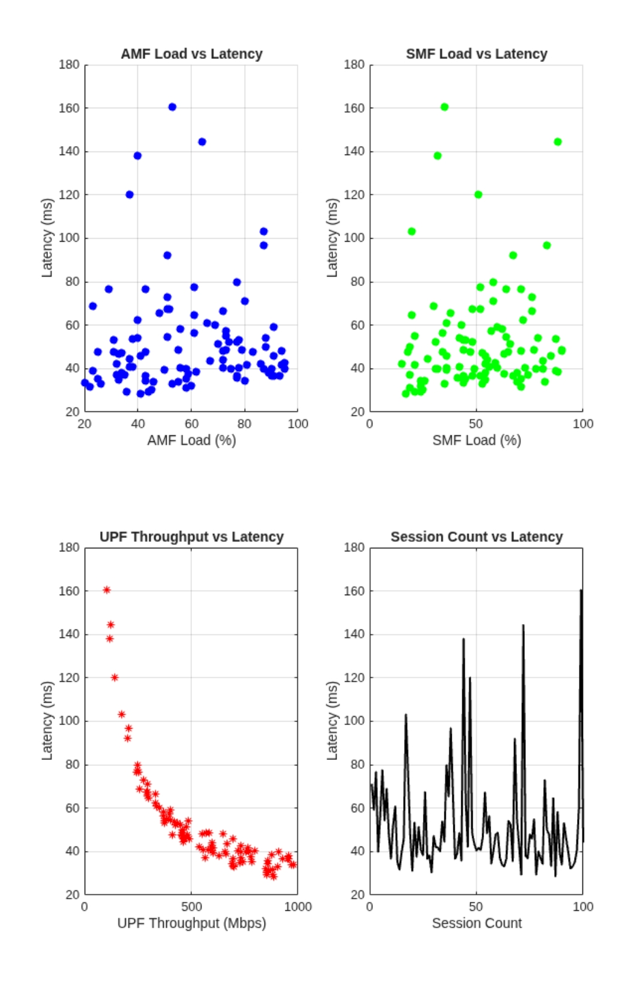

2. Edge Computing Delay Simulation
clc; clear; close all;

% Simulation Parameters
SNR_dB = 0:2:30; % SNR range in dB
SNR_linear = 10.^(SNR_dB / 10);
B = 20e6; % Bandwidth = 20 MHz
multiplexingOrder = [1, 2, 4, 8]; % Antenna Configurations (N x N MIMO)

figure;
hold on; grid on;
colors = ['r', 'g', 'b', 'm'];

% Capacity Calculation over Rayleigh Fading
for idx = 1:length(multiplexingOrder)
Nt = multiplexingOrder(idx); % Tx Antennas
Nr = Nt; % Rx Antennas

C = zeros(1, length(SNR_dB));
numTrials = 500; % Rayleigh Channel realizations

for k = 1:length(SNR_linear)
snr = SNR_linear(k);
cap_sum = 0;
for t = 1:numTrials
H = (randn(Nr, Nt) + 1i*randn(Nr, Nt)) / sqrt(2); % Rayleigh Channel
cap_sum = cap_sum + real(log2(det(eye(Nr) + (snr / Nt) * (H * H'))));
end
C(k) = (cap_sum / numTrials) * (B / 1e6); % Capacity in Mbps
end

plot(SNR_dB, C, [colors(idx) '-o'], 'LineWidth', 1.5, 'DisplayName', sprintf('%dx%d MIMO', Nt, Nr));
end

xlabel('SNR (dB)');
ylabel('Channel Capacity (Mbps)');
title('MIMO Capacity vs SNR under Rayleigh Fading');
legend('Location', 'NorthWest');

% Print Summary Results
fprintf('Maximum Capacity achieved at 30 dB SNR:\n');
for idx = 1:length(multiplexingOrder)
fprintf('%dx%d MIMO: %.2f Mbps\n', multiplexingOrder(idx), multiplexingOrder(idx), C(end));
end

OUTPUT 